Appendix E Instructions

For Regular Title Series Faculty

- Go to http://nimss.umd.edu/
- Click on member login and Registration
- Enter login and password
- If you are certain you do not have an existing login and password click on register and complete registration as follows:
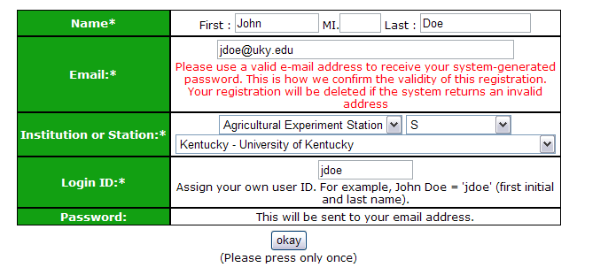

- In the green bar hold cursor over participants
- Hold cursor over draft/Edit Participant Info
- Click on Draft New
- Select region from drop down box
- Select project from drop down box
- If you are the official station representative click on box (if not leave blank)
- Choose appropriate objectives for your project
- Scientific Year (A full-time equivalent research scientist)
- Professional Year (A full-time equivalent graduate student or postdoctoral research associate)
- Technical Year (A full-time equivalent technical support staff person)
- Click on Knowledge Area
- Click on Subject of Investigation
- Click on Field of Science
- Click on submit

